
COLLEGE OF COMPUTER STUDIES

CCS007L (COMPUTER PROGRAMMING 2)

EXERCISE
3

CHARACTER AND STRING MANIPULATION

Student Name / Group Name:
Jed L. Hizon
Name Role

Members (if Group):

AN11 – 2nd Term
Section:
Mr. Mark Cezar

Professor:

I. PROGRAM OUTCOME/S (PO) ADDRESSED BY THE LABORATORY EXERCISE

• Apply knowledge through the use of current techniques and tools necessary for the IT profession. [PO: I]

II. COURSE LEARNING OUTCOME/S (CLO)ADDRESSED BY THE LABORATORY EXERCISE

• Adapt and apply appropriate techniques, resources, and modern computing tools to create computing applications [CLO: 3]

III. INTENDED LEARNING OUTCOME/S (ILO) OF THE LABORATORY EXERCISE

At the end of this exercise, students must be able to:

• Create a program that applies different C-String functions

• Create a program process C-String values using user-defined functions

IV. BACKGROUND INFORMATION

A string stored as an array of characters terminated with ‘\0’.

Table 1: Some Predefined C-String Functions in <cstring> FUNCTION DESCRIPTION
strcpy(Target_String_Var,Src_String) Copies the C-string value Src_String into the C-string variable Target_String_Var
strcpy(Target_String_Var,Src_String,limit) The same as the two argument strcpy except that at most Limit characters are copied
strcat(Target_String_Var,Src_String) Concatenates the C-String value Src_String onto the end of C-string in the C-string variable Target_String_Var
strcat(Target_String_Var,Src_String, The same as the two argument strcat except that at most Limit) Limit characters are appended.
strlen(Src_String) Returns an integer equal to the length of Src_String. (The null character, ‘\0’, is not counted in the length.
strcmp(String_1, String_2) Returns 0 if String_1 and String_2 are the same. Returns a value < 0 if String_1 is less than String_2. Returns a value > 0 if String_1 is greater than String_2 (that is, returns a nonzero value if String_1 and String_2 are different). The order is lexicographic.
strcmp(String_1, String_2, Limit) The same as the two-argument strcmp except that at most Limit characters are compared.

CCS007L-Computer Programming 2 Page 2 of 8

Table 2 : Some Predefined character manipulating functions in <cctype> FUNCTION DESCRIPTION
toupper(Char_Exp) Returns the uppercase version of Char_Exp (as value of type int). tolower(Char_Exp) Returns the lowercase version of Char_Exp (as value of type int). isupper(Char_Exp) Returns true provided Char_Exp is an uppercase letter; otherwise, returns false. islower(Char_Exp) Returns true provided Char_Exp is an lowercase letter; otherwise, returns false. isalpha(Char_Exp) Returns true provided Char_Exp is a letter of the alphabet; otherwise return false. isdigit(Char_Exp) Returns true provided Char_Exp is one of the digits ‘0’ through ‘9’; otherwise,
returns false.
isalnum(Char_Exp) Returns true provided Char_Exp is either a letter or a digit; otherwise, returns false. isspace(Char_Exp) Returns true provided Char_Exp is a whitespace character, such as the blank or
newline character, otherwise, return false.
ispunct(Char_Exp) Returns true provided Char_Exp is a printing character other than whitespace, a digit, or a letter; otherwise return false.
isprint(Char_Exp) Returns true provided Char_Exp is a printing characters includes blank space; otherwise returns false.
isgraph(Char_Exp) Returns true provided Char_Exp is a printing characters; otherwise returns false. isctrl(Char_Exp) Returns true provided Char_Exp is a control character; otherwise, return false.

CCS007L-Computer Programming 2 Page 3 of 8

VI. GRADING SYSTEM/ RUBRIC

Trait

Requirement Specification(30pts)

Data type(20pts)

Input Validation(20pts)

Free from syntax, logic, and runtime errors (10pts)

Delivery (10pts)

Use of Comments (10pts)
(Excellent) Able to identify
correctly all input and output and provide alternative.
(28-20pts)

Able to apply required data type or data structure and produce correct results (18-20pts)
The program works and meets all specifications. Does exception al checking for errors and out-of- range data (18-20pts) Unable to run program (10pts)

The program was delivered on time (10pts)

Specific purpose is noted for each function, control structure, input requirements, and output results. (10pts)
(Good)
Able to identify correctly all input and output
(25-17pts)

Able to apply required data type or data structure and produce partially correct results (15-17pts) The program works and meets all specifications. Does some checking for errors and out of range data (15-17pts) Able to run program but have logic error (8-9pts)

The program was delivered after 5 minutes from the time required. (8-9pts)

Specific purpose is noted for each function and control structure. (8-9pts)
(Fair)
Able to identify only one input or output (22-14pts)

Able to identify required data type or data structure but does apply correctly (12-14pts)

The program produces correct results but does not display correctly Does not check for errors and out of range data (12-14pts)
Able to run program correctly without any logic error and display inappropriate output (6-7pts)

The program was delivered after 10 minutes from the time required. (6-7pts)

Purpose is noted for each function. (6-7pts)
(Poor) Unable to
identify any input and output
(20-11pts)

Unable to identify required data type
(9-11pts)

The program produce s incorrect results (9-11pts)

Able to run program correctly without any logic error and display appropriate output (5pts) The program was delivered after 15 (or more) minutes from the time required. (5pts)
No comments included. (5pts)

CCS007L-Computer Programming 2 Page 4 of 8
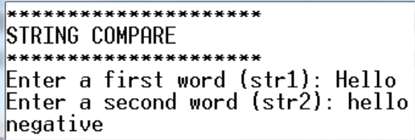
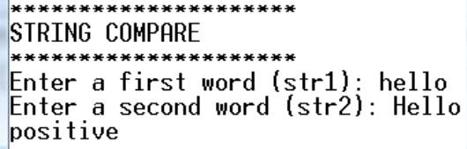
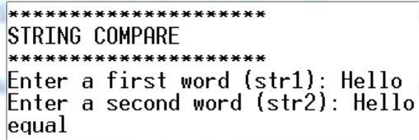

VII.LABORATORY ACTIVITY

INSTRUCTIONS:
Copy your source codes to be pasted in this document as well as a screen shot of your running output.

ACTIVITY3.1: Compare two strings
Create a program that will compare two input strings using strcmp( ).

EXAMPLE PROGRAM OUTPUT:

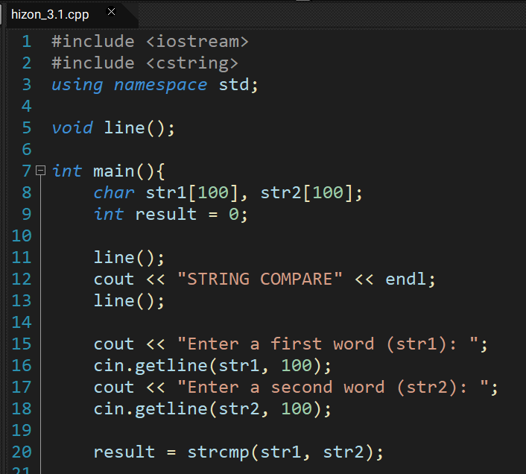
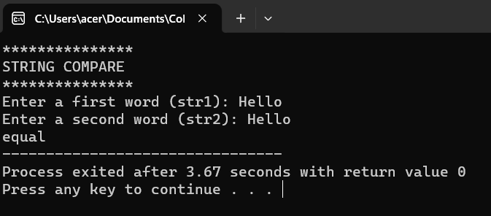
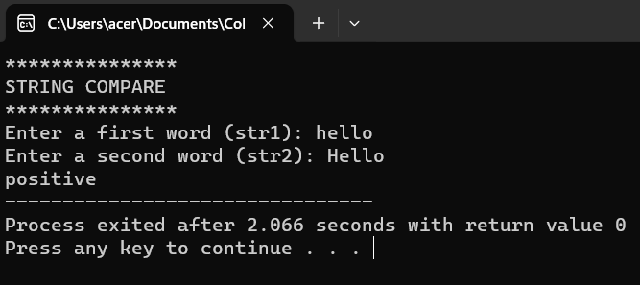
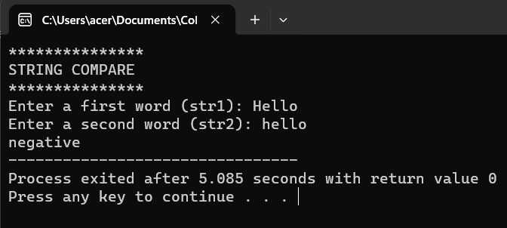
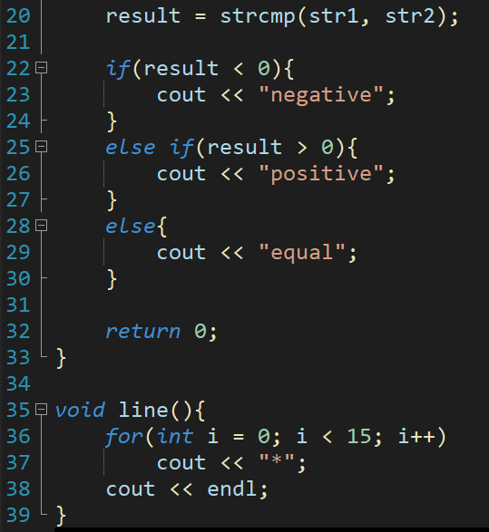

ACTIVITY 3.2: Copying strings
Create a program that will copy a string from one variable to another using the strcpy( ) function.

EXAMPLE PROGRAM OUTPUT:

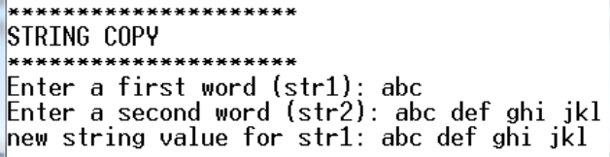
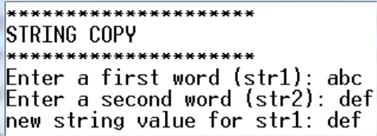

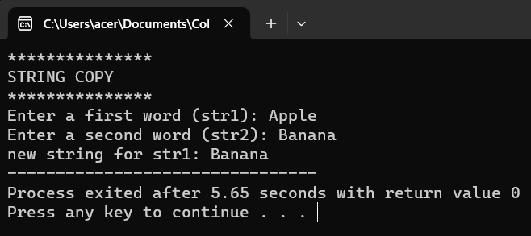

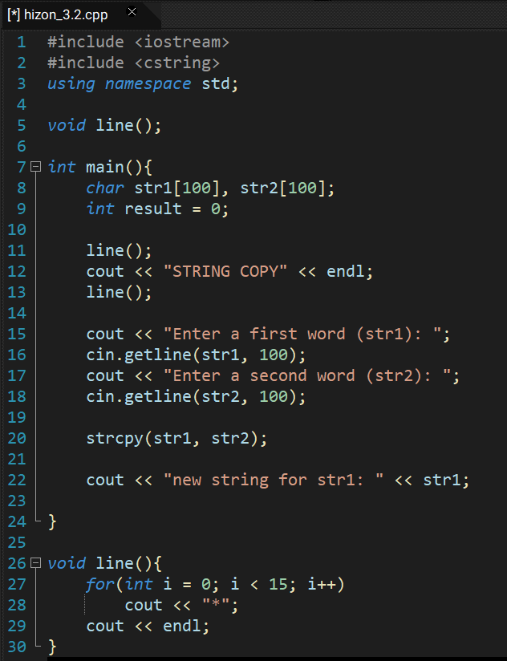

CCS007L-Computer Programming 2 Page 5 of 8
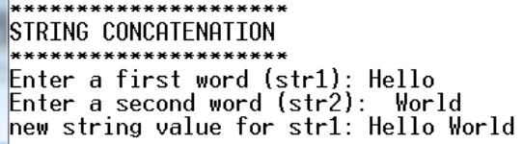
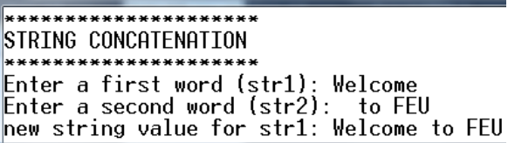
ACTIVITY 3.3: Concatenating strings Create a program that will concatenate two strings.

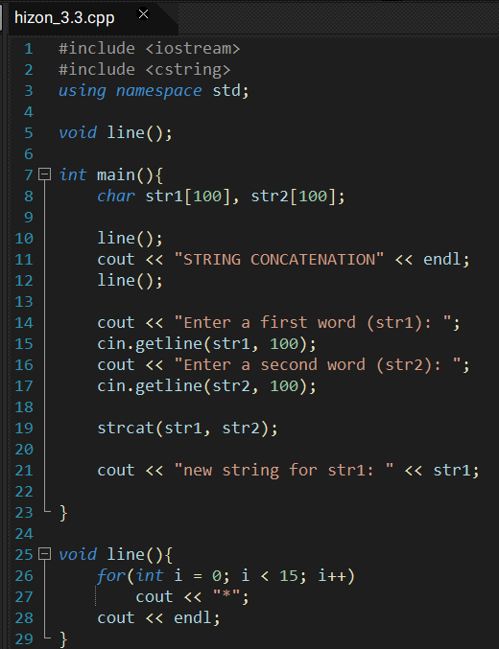
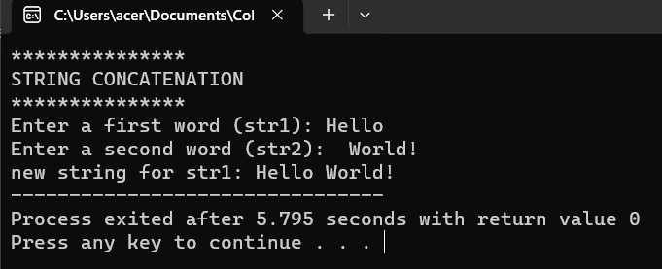
ACTIVITY 3.4: Palindrome
Convert a program that will determine if the given word input is a palindrome using C-String functions.

NOTE: Palindromes are words that are read the same way either left to right or right to left.

EXAMPLE PROGRAM OUTPUT:

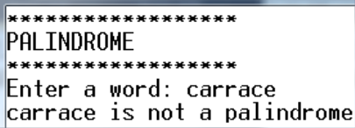
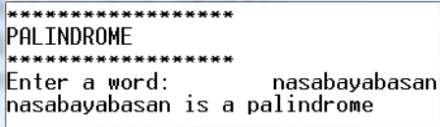
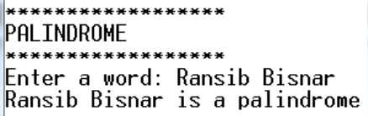
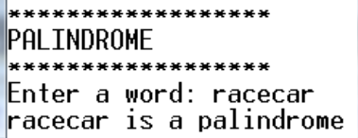

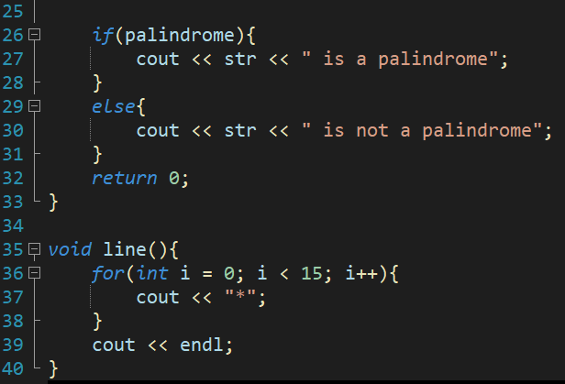
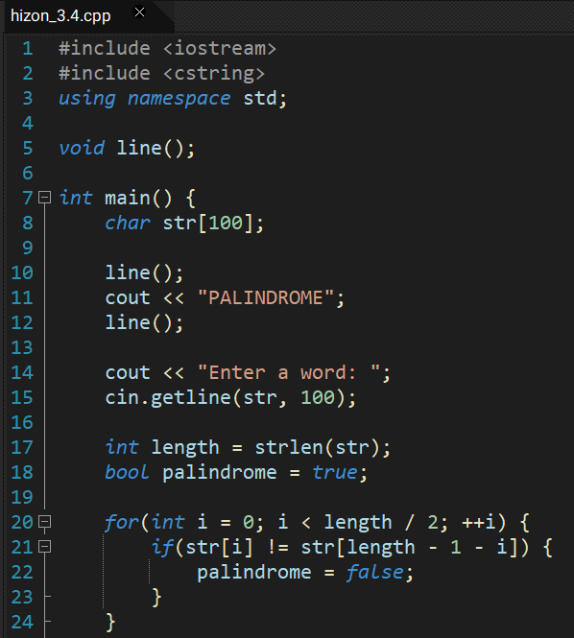
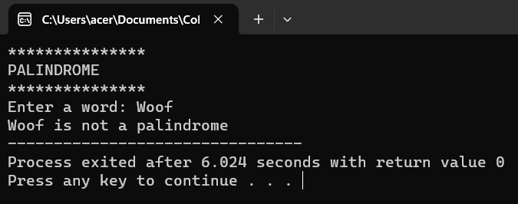
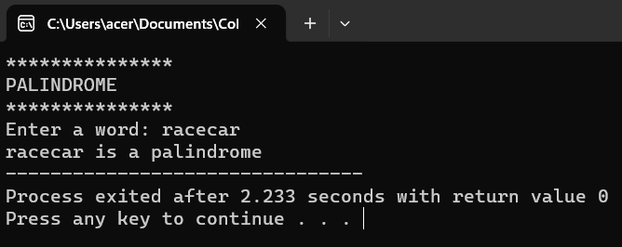
ACTIVITY 3.5: Uppercase
Create a program that will accept an input string. Display the same string in all capital form.

EXAMPLE PROGRAM OUTPUT:
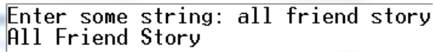
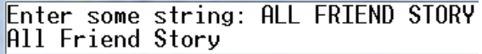

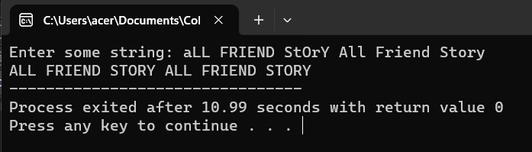
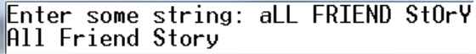

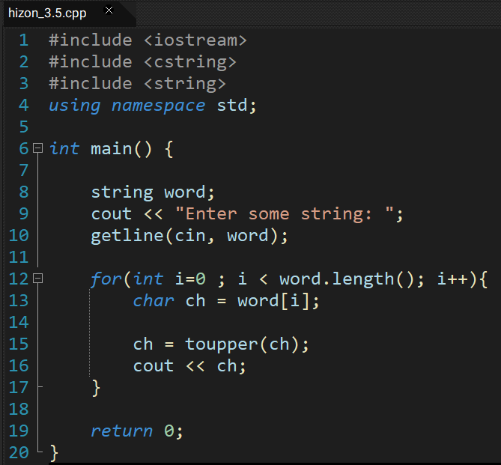

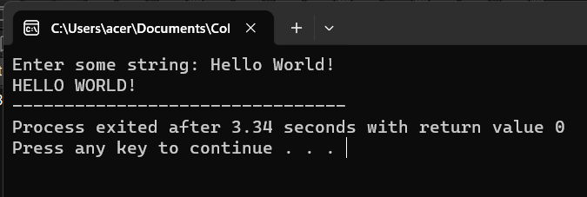

CCS007L-Computer Programming 2 Page 6 of

ACTIVITY 3.6: Strings to words
Create a program that will ask the user to enter some string. The program will split the string in to word and display in reverse vertical order.

EXAMPLE PROGRAM OUTPUT:

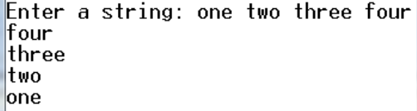
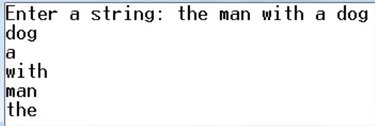

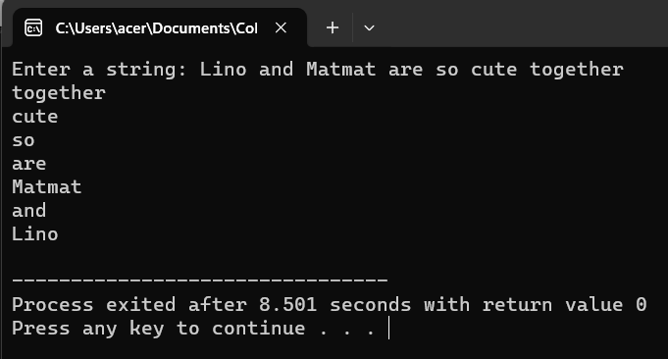
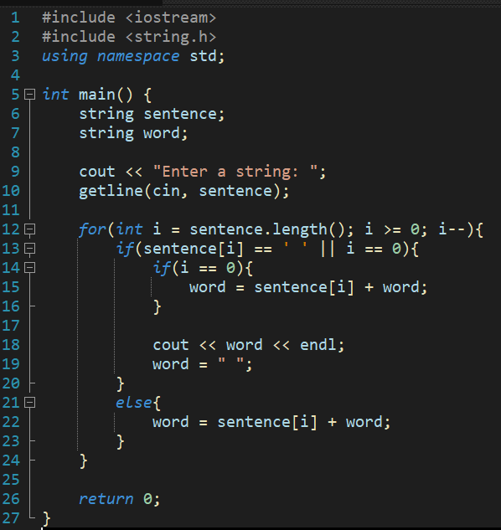
VIII. QUESTION AND ANSWER

Briefly answer the questions below. Avoid erasures. For group activity, specify the name of GROUP MEMBER/s who answered the question. Do not forget to include the source for all NON-ORIGINAL IDEAS.

• What is a String?
is a sequence of characters, typically used to represent text. These characters can include letters, numbers, symbols, and whitespace.

• What is cctype?
The C++ <cctype> header file declares a set of functions to classify (and transform) individual characters. For example, isupper() checks whether a character is uppercase or not.

• What is cstring?
In the context of programming in C or C++, a CString typically refers to a null-terminated array of characters, commonly known as a C-style string. It is a fundamental data type used for representing and manipulating text data within these languages.

CCS007L-Computer Programming 2 Page 7 of 8

IX. REFERENCES
• Zak, Dianne (2016). An Introduction to Programming with C++
• Deitel, Paul & Deitel, Harvey (2012). C++ How To Program, Eighth Edition https://www.cprogramming.com/tutorial/lesson9.html

CCS007L-Computer Programming 2 Page 8 of 8

